Little SPARK: Simple Play Adaptations to Reference for Kids

Quiet Ears Ear Muffs
Description: | Image:
The Quiet Ears Ear Muffs are designed to provide noise protection for young children so that loud noises in the environment are reduced to a more comfortable level. Child sized for snug fit.  Instructions:  - Simply pull down on the ear cups to adjust the size!  Cleaning:  - Use warm soapy water. May be disinfected with alcohol. | 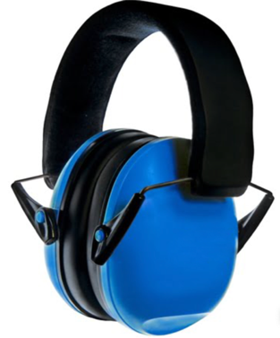  Purchasing Information  Demo Video

Who Might Benefit?
Children who are sensitive to unexpected noises, loud environments, or prefer the quiet to focus and concentrate.
Why Use?
This is a way to reduce the noise in loud environments and help the child feel comfortable to play.
Instructions for Use: | Adaptation Ideas:
Environmental Considerations  - The ear muffs can be used in any environment where the child is bothered by continuous environmental noises or sudden unexpected noises.  - It is not recommended that the ear muffs be used continuously throughout the day.  Basic Play/Use  - Observe the child for signs of sound sensitivities (e.g. covering ears, agitation, anger, anxiety, etc.).  - Ask the child to identify if the noise is too loud and have the muffs available at their request. | Communication Supports  - Visual supports, like a volume meter scale, may be used for children to indicate when an environment is getting too loud.  - Use social narratives to prepare the child for unexpected loud noises and how to request the ear muffs when needed.  Alternatives  - Typical cold weather ear muffs may dampen unwanted sounds slightly.  - Try using headphones with music or ambient noise to safely mask disruptive environmental sounds.

Words to Encourage Play/Use
Loud  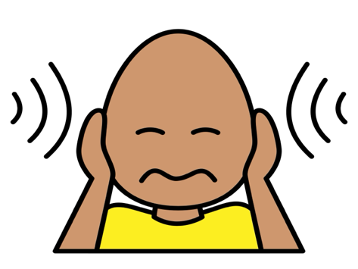 | Quiet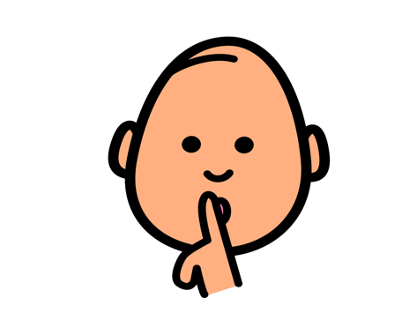 | Wait 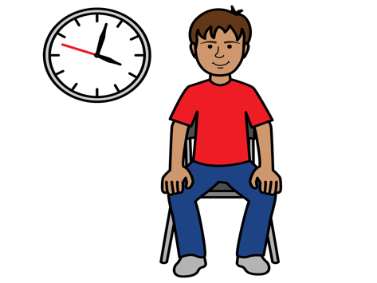
Stop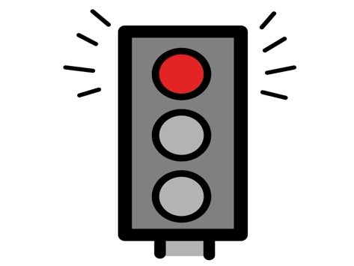 | Go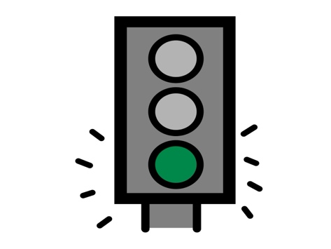 | Help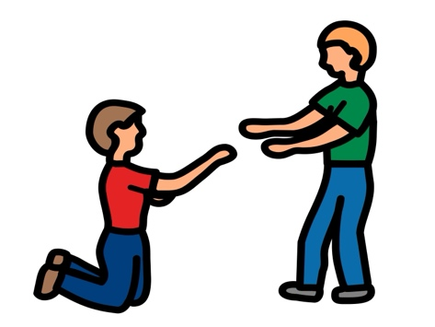
On 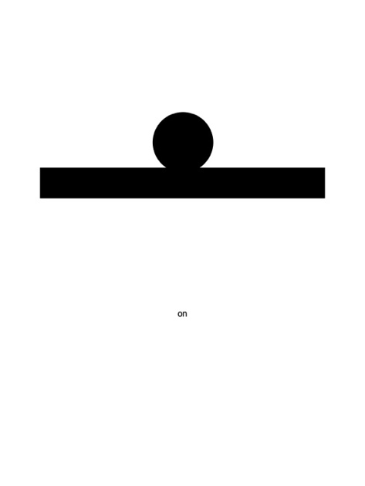 | Off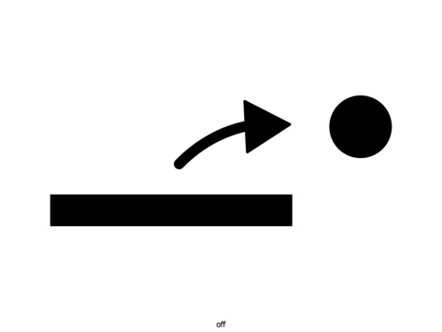 | Ears  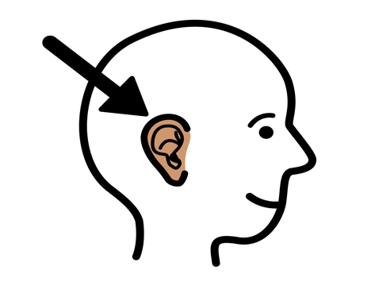
*”Adaptations” adapted from: Haugen’s Modes for Adapting Toys based on materials from the "Let's Play" Project at the University of Buffalo
PCS is a trademark of Tobii Dynavox, LLC. All rights reserved. Used with permission.

